**VALUE BASED PURCHASING**

IT IS ONE OF **VALUE BASED PAYMENT PROGRAMS** administered by the Centre of Medicare and Medicaid Services (CMS)

Let's first discuss Value-Based Payments.

* Historically hospitals in the USA were paid by insurance companies for everything they do based on the bulk of patients they used to treat. This is called "Fee For Service"

* In comparison to other wealthy countries, the US healthcare system is doing very badly if you look at objective measurements of the USA

* And their performance on various things like "Access to Care", "Administrative Efficiency", "Health Equity", and "Health Outcomes", the USA is dead last on each of these parameters.

SO THE PROBLEM WITH FEE FOR SERVICE MODEL IS THAT THE HOSPITAL IS INCENTIVISED FOR THE VOLUME OF CARE THAT THEY PROVIDE AND NOT NECESSARILY FOR THE VALUE OF CARE THAT IS PROVIDED

* The USA government has signed "The ACA" **{AFFORDABLE CARE ACT, 2010}.**

* Designed to expand people's access to health insurance but also contained provisions for restructuring how hospitals get paid.

their goal was to satisfy a phrase coined by the Institute of Healthcare called the "TRIPLE AIM".

* **Triple Aim** has 3 strategies-

1) Improve the experience of care for the patients

2) Reduce health care costs per person

3) Improve the health of populations

* The ACA ushered the US healthcare system into an era of payment reform system

* It resulted in different ways to incentivize hospitals for good care and penalize them for bad care with programs such as

VM-----"VALUE MODIFIER PROGRAM"

HRRP---"HOSPITAL READMISSION REDUCTION PROGRAM"

HACRP--"HOSPITAL-ACQUIRED CONDITIONS REDUCTION PROGRAM"

HVBP---"HOSPITAL VALUE-BASED PURCHASING PROGRAM"

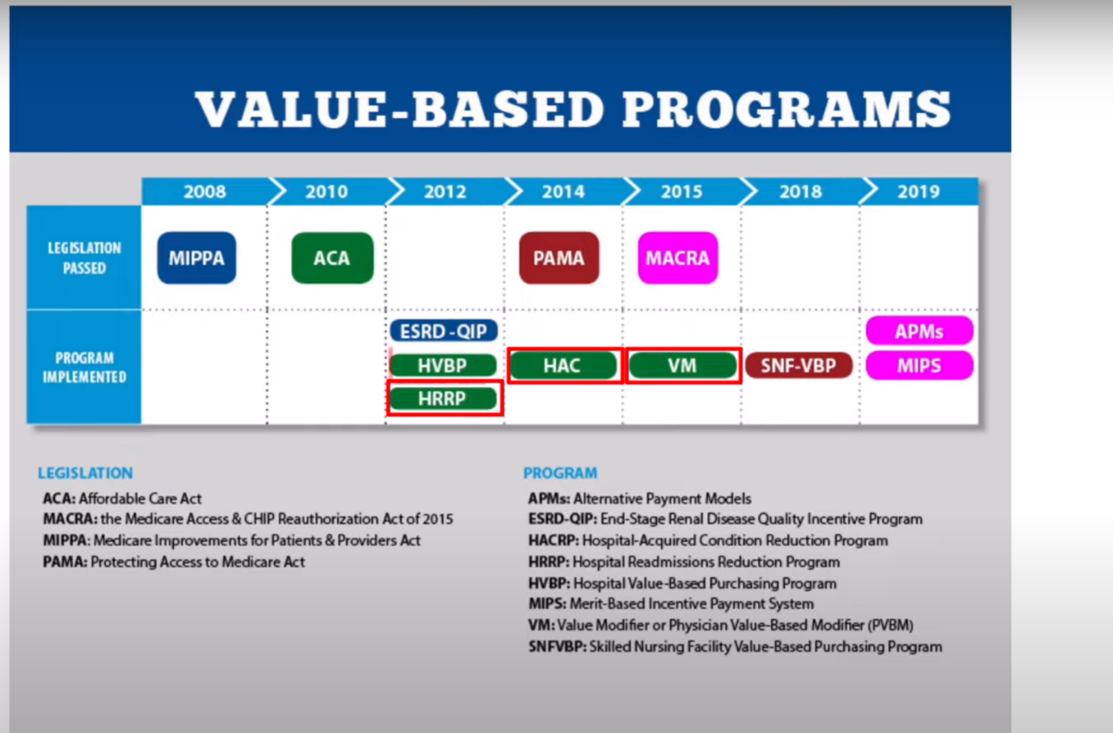

Now lets talk about 'HVBP' - Value Based Purchasing program.

There are actually 2 value based purchasing programs-

1) SNF-VBP = Skilled Nursing Facility VBP

2) H-VBP = Hospital VBP

**Lets talk about H-VBP**

* In the H-VBP, over 3,000 hospitals in US have their payments adjusted based off of the quality of care that they provide by each fiscal year.

* As of fiscal year 2024, The Quality of the Hospitals care that they provide is evaluated against measures in 4 domains.

* These are :-

1) 6 measures in CLINICAL OUTCOMES

2) 5 measures in SAFETY

3) 1 measures in EFFICIENCY

4) 8 measures in PERSON & COMMUNITY ENGAGEMENT

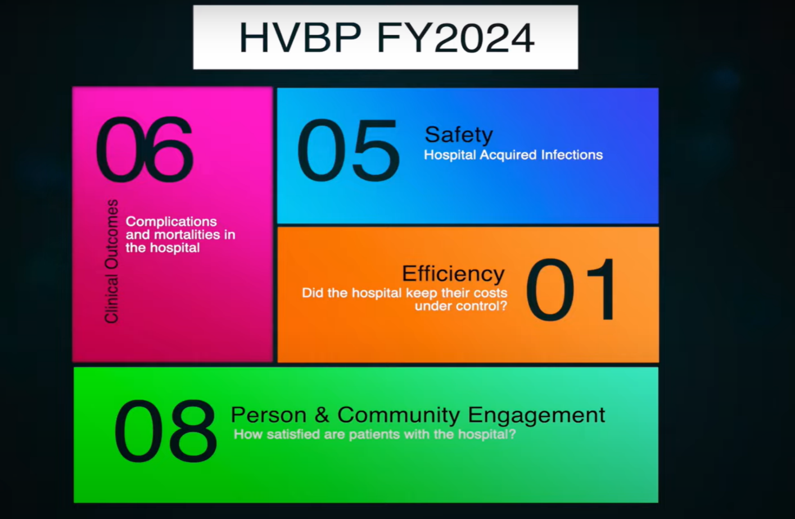

The **'Clinical Outcomes' domain** pertains the things like what was our complication rate after doing

1) total hip and knee replacements

2) what was our rate of patients dying in 30 days of some events like COPD, Acute MI, CABG, Pneumoniae

[https://d15k2d11r6t6rl.cloudfront.net/public/users/Integrators/669d5713-9b6a-46bb-bd7e-c542cff6dd6a/a8e16746030542259a008c5feabcd187/editor_images/Frame 31613004 copy.png](https://d15k2d11r6t6rl.cloudfront.net/public/users/Integrators/669d5713-9b6a-46bb-bd7e-c542cff6dd6a/a8e16746030542259a008c5feabcd187/editor_images/Frame%2031613004%20copy.png)

The **'Safety' domain** looks at things like how often the patient acquired infections while they were a patient in our hospitals, so these are things like

1) Surgical Sight Infections in Colon Surgeries and Abdominal Hysterectomies,

2) Catheter Associated Urinary Tract Infections (CAUTIs),

3) Central line Associated bloodstream infections(CLABSIs)

4) CDIFF, MRSA

The **'Efficiency & Cost Reduction' domain** looks at how much spending there was per

Medicare patients in the hospitals

The **'Person & Community Engagement' domain** –

1) It is somewhat different from the others!

2) The measures in this one come from a survey called HCAHPS

**WHAT IS HCAHPS???**

It is a survey given to patients in a hospitals that assess the quality of the care that was provided and whether or not the patient was satisfied with their experience

HCAHPS will ask the patients things like

1) "Did the patient and nurses communicate with you well?" (Never, Sometimes, Usually, Always)

2) "Did they provide adequate discharge instruction to you" (Never, Sometimes, Usually, Always)

3) "Was hospital always quiet at night and clean?" (Never, Sometimes, Usually, Always)

4) "What % of Patients rated the hospital a 9 or 10" (Out of 10)

**Topbox score** -

* "Always"/"Strongly Agree"

* Hospitals aim for this

* The percentage of patients that answered in the top box in the question is collected from HCAHPS and submitted to CMS

* To Assess how often that hospital provided excellent care.

**So how the performance is assessed on all these measures ??**

----The general idea is that there are 2 time periods

1) Baseline period

2) Performance Period

* **For each measure within each of the 4 domains, the hospitals have 2 ways of scoring points on each of their measures**.

1) They can score **IMPROVEMENTS SCORES** - where the points are awarded based on how much the hospital improved in the performance period compared to their performance in the Baseline period a couple of years prior

2) The hospital can also score **ACHIEVEMENT SCORES** - The points are awarded based on How well the hospital was able to get close to or beat the top 10% of hospitals from the Baseline period with their rate in the performance period.

* Each measure is scored separately for these 2 methods and the highest score of the 2 methods yields the final points for that measure.

* Now a bunch of formulas are there to determine how much the hospital ends up getting paid

* The Methodology of how payment is distributed can be studied from this link

<https://hcahpsonline.org/>

https://hanys.askflorence.org/Data//C...

https://www.qualityreportingcenter.co...

<https://datawizardry.academy/pivot-into-clinical-analytics/>

* Every year CMS sets aside 2% of the total reimbursement that they pay each hospital for Medicare Inpatients

* Depending on the score of the hospital, some of the hospitals will not earn any of the 2% if they performed poorly, some will earn a portion of that 2% and the best one will earn 2% + Bonus